## ISYS3356 – User-Centred Design

## **Practical Assessment – HTML,CSS (worth 20%)**

## **The due date is the 23rd of May 2025 COB (5:30 pm)**

# Overview

Create a website for a fictitious pet adoption agency – Pets Victoria that will display pets available for adoption.

The assignment is an individual task that will require an individual submission.

Please ensure that you submit your assignment to the Canvas (Assignments)

Assessments submitted after the due date will be accepted as follows:

* Assessments submitted between 0-24 hours after the due date: 20% penalty.
* Assessments submitted between 24-48 hours after the due date: 50% penalty.
* Assessments submitted more than 48 hours after the due date will not be accepted.

**Extensions**

If you will not be able to meet the due date for an assessment you may apply to your teacher for an extension of up to seven days by completing the Application of Time to Submit Assessment Work Format <https://www.rmit.edu.au/content/dam/rmit/documents/Students/Student_forms/Application-for-extension-of-time-to-submit-work.pdf> Applications for an extension of time must be received at least one working day before the due date for an assessment.

**Special Consideration**

If unforeseen circumstances beyond your control prevent you from submitting your work on time you may be eligible to apply for special consideration. For further information regarding special consideration, please refer to the RMIT Special Consideration page at <https://www.rmit.edu.au/students/student-essentials/assessment-and-results/special-consideration>

**Academic integrity**

In addition to meeting assessment timelines academic integrity is about honest presentation of academic work. Students must be accountable for the originality and validity of assessment submission, and not assist others in any form of plagiarism or cheating.

<https://www.rmit.edu.au/students/student-essentials/assessment-and-exams/academic-integrity>

**AI TOOLS AND THEIR USE ARE NOT RESTRICTED FOR THIS ASSESSMENT TASK**

In this assessment task, you can use AI tools to assist you. All use of AI tools and their outputs should be appropriately acknowledged and referenced.

Create a website for a fictitious pet adoption agency – Pets Victoria according to the following basic requirements:

1. All pages should use semantic HTML 5 elements like header, nav, main and footer (as discussed in week 2) and well-structured content according to the following instructions.
2. Include the logo (logo.jpeg) in the navigation bar and link it to the home page (index.html). The navigation bar should have a search form, but the search functionality is not required.
3. The main image (main.jpg) should be included as an image element in the main section of the page (home page only). The image should float right and should be displayed as a circle. Use CSS for that.
4. All pages should have a footer with a copyright that has your name.
5. There should be **one** common CSS file for all the pages (for common nav and footer styles). You must create a CSS stylesheet that all pages are linked to (in the <head> element).
6. Use a float for layout rather than absolute positioning.
7. The content of the page is 1200px wide and centred. Use margins on the body element to achieve this.
8. Use Google fonts for the site. “Ysabeau SC” as a default, “Poetsen One” for all headings except for <h1> on the home page – “Permanent Marker”, and material icons for icons.

You can have a look at the examples <https://fonts.google.com/specimen/Permanent+Marker>, <https://fonts.google.com/specimen/Ysabeau+SC>, <https://fonts.google.com/icons>, https://fonts.google.com/specimen/Poetsen+One

1. Each html page should be validated against W3C standards at <https://validator.w3.org/>. You should validate all your HTML files and the CSS file. Correct and re-test issues. Fix any errors or warnings.
2. Please use the techniques taught in this course so far; do not use Bootstrap or other frameworks for any functionality.

**Please do not upload individual files – zip up your work and upload that.**

Make sure that you follow the naming convention for files and directories. Failure to do so will result in lost marks.

# **Create the following 4 Web Pages according to the instructions given for this website.**

**1. index.html**

As given in the below picture. Check the images provided on Canvas. Add your name in the copyright footer (The name should be the same as your Canvas name).

2. **pets.html**

Create a table to describe pets with some information like name, type, age, and location.

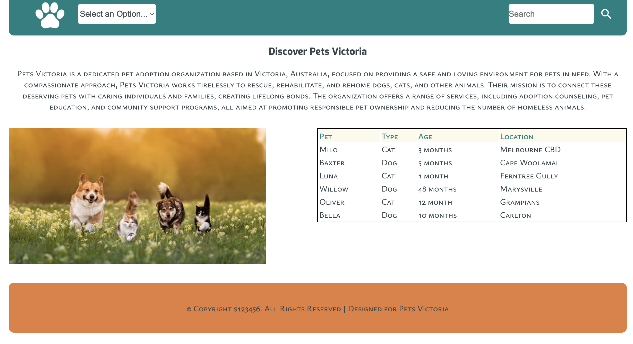

**Check the following link to learn more about the form element.**

<https://www.w3schools.com/html/html_forms.asp>

**3. gallery.html**

Create a picture gallery presenting pictures of the pets.

You can use the images provided, or you can search for images on the following sites:

<https://pxhere.com/> or <https://pixabay.com/>

Alternatively, you can use other Adobe Stock images. If you use the images provided or find other Adobe Stock images, place a copyright notice in your code - “All images used are from [Adobe Stock](https://aus01.safelinks.protection.outlook.com/?url=https%3A%2F%2Fstock.adobe.com%2Fau%2F&data=05%7C01%7Ctanya.unterberger%40rmit.edu.au%7Ccb2a1bef4b644bb6bfa608da559b560f%7Cd1323671cdbe4417b4d4bdb24b51316b%7C0%7C0%7C637916422892529150%7CUnknown%7CTWFpbGZsb3d8eyJWIjoiMC4wLjAwMDAiLCJQIjoiV2luMzIiLCJBTiI6Ik1haWwiLCJXVCI6Mn0%3D%7C3000%7C%7C%7C&sdata=cThyn5UI8l4KOS4Yi1M6cBL0Y%2Fpp39sCBksYVdwU%2FWo%3D&reserved=0) and used under [RMIT Education License](https://aus01.safelinks.protection.outlook.com/?url=https%3A%2F%2Fstock.adobe.com%2Fau%2Fenterprise-conditions%23educationLicenses&data=05%7C01%7Ctanya.unterberger%40rmit.edu.au%7Ccb2a1bef4b644bb6bfa608da559b560f%7Cd1323671cdbe4417b4d4bdb24b51316b%7C0%7C0%7C637916422892529150%7CUnknown%7CTWFpbGZsb3d8eyJWIjoiMC4wLjAwMDAiLCJQIjoiV2luMzIiLCJBTiI6Ik1haWwiLCJXVCI6Mn0%3D%7C3000%7C%7C%7C&sdata=6aJzYJm9cAfbmolG8hgnB9EYw5uqAB4OzeYjIGPpeZA%3D&reserved=0)”. This can be done as a comment on every page.

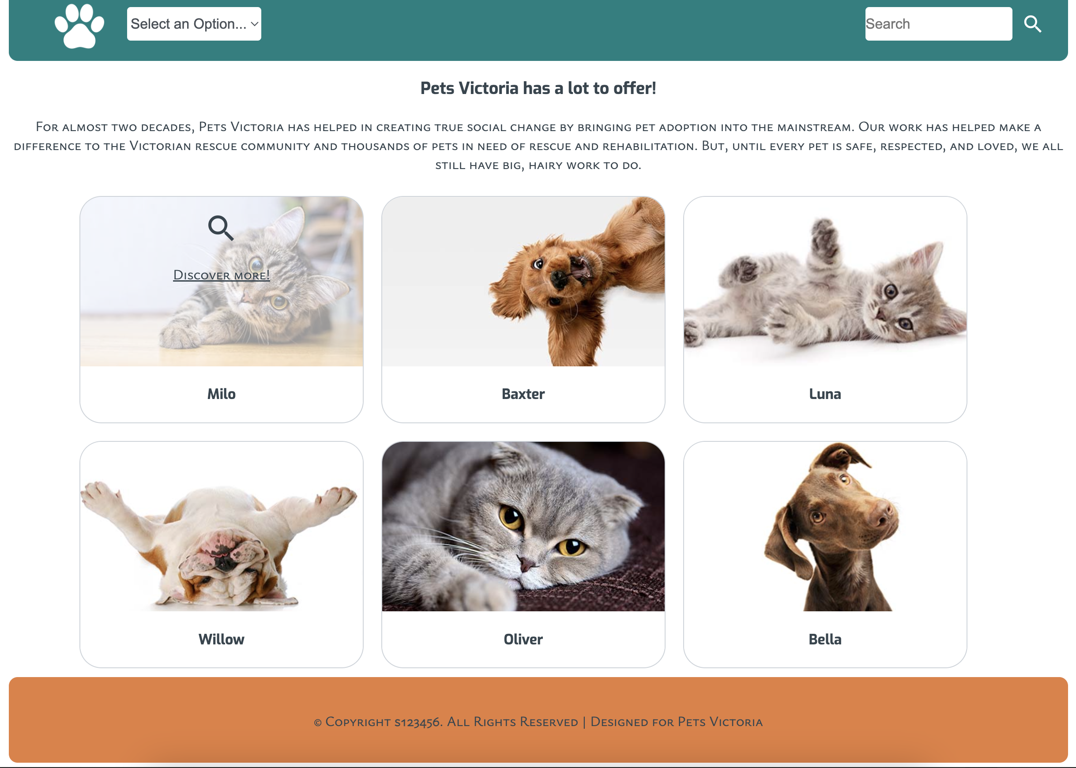

**Colours Used**

* #36454F (text)
* #E57F3D (h1, footer background, on hover, etc.)
* #008080 (nav background, h2, th, footer text, etc.)
* #fcf9ec (home page main background)

**Instructions for submission of your website on Canvas**

Please submit the zipped-up ***wp/a1*** directory that should contain the following files:

1. index.html
2. pets.html
3. gallery.html
4. style.css (in *css* folder)
5. Provided image files for the logo and the main page and images that you are including in the gallery page in the *images* folder.
6. Test.docx with screenshots of the validated html pages and the css file

**Rename your zipped-up folder with your lastname_firstname_studentID and upload the zip file to Canvas. The assessment task will have a file upload section.**

**Please do not upload individual files – zip up your work and upload that.**

Make sure that you follow the naming convention for files and directories. Failure to do so will result in lost marks.

## **Marking Guide for Web Programming Assessment 1**

**Assessment worth 20% Mark**

|  |  |
| --- | --- |
| **Element to be marked** | **Total marks** |
| Complete zipped up folder according to the instructions | 1 |
| Home page (index.html) according to the given instructions and html is validated. | 3 |
| The About page (pets.html) is according to the given instructions. The page has valid html. | 3 |
| The Gallery page (gallery.html) is according to the given instructions. The page has valid html. | 3 |
| One separate css file with all the required styles. No inline css used | 2 |
| Float used for layout | 1 |
| Google fonts are correctly used for the site | 2 |
| All pages have valid html. Screenshots of the validated html page are submitted in a Test.docx document | 4 |
| Site has valid css. Screenshots of the validated css file are submitted in a Test.docx document | 1 |
| **Total marks** | **20** |

**Note: The teacher may ask any student for a demonstration to validate their work**